🔹 Problem Saga Solves
In microservices:
- Each service has its own database.
- A business process (like placing an order) usually needs to update multiple services.
Example: Order → Inventory → Payment → Shipping.
👉 A single distributed transaction (ACID) across all databases is not practical.
👉 If one step fails, you must roll back or compensate the earlier steps.
Saga = a way to manage distributed transactions across microservices.

🔹 What is a Saga?
A Saga is a sequence of local transactions in different services.
- Each local transaction updates its own database.
- After completing, the service publishes an event to trigger the next step.
- If one step fails, the Saga executes compensating transactions to undo or fix previous steps.

🔹 Two Saga Styles

🔹 1. Saga with Choreography (Event-Driven)
How it works:
- No central controller.
- Each service publishes events and listens to events from others.
- The flow is driven decentrally by services themselves.

📦 Example (E-commerce Order Saga):
- Order Service: Customer places order → creates order in DB → publishes OrderCreated event.
- Inventory Service: Listens to OrderCreated → reserves stock → publishes InventoryReserved.
- Payment Service: Listens to InventoryReserved → processes payment → publishes PaymentAuthorized.
- Shipping Service: Listens to PaymentAuthorized → creates shipment → publishes ShipmentCreated.
- Order Service: Listens to ShipmentCreated → updates order state to Shipped.
Failure case (Payment failed):
- Payment Service publishes PaymentFailed.
- Order Service listens and marks order Cancelled.
- Inventory listens to PaymentFailed → releases reserved stock.

✅ Advantages:
- Simple to start (just publish & subscribe).
- No single orchestrator service (no central bottleneck).
- Scales well for small-to-medium workflows.

❌ Disadvantages:
- Hard to trace/debug because control is spread across many services.
- Complex flows with many compensations can become “event spaghetti”.

🛠 Technical Implementation (Choreography):
- Use a message broker: Kafka, RabbitMQ, Azure Service Bus.
- Each service has:
  - A local transaction (DB update).
  - An Outbox table for events (Outbox Pattern).
  - A publisher that sends events reliably.
  - A subscriber that reacts to events.

🔹 2. Saga with Orchestration (Central Coordinator)
How it works:
- A dedicated Orchestrator Service manages the saga flow.
- It sends commands to services and waits for replies/events.
- Orchestrator holds the state machine of the saga.

📦 Example (E-commerce Order Saga):
- Order Orchestrator: Receives PlaceOrder command.
- Orchestrator → tells Inventory: ReserveStock.
- Inventory → responds with StockReserved.
- Orchestrator → tells Payment: AuthorizePayment.
- Payment → responds with PaymentAuthorized.
- Orchestrator → tells Shipping: CreateShipment.
- Shipping → responds with ShipmentCreated.
- Orchestrator → marks saga complete, updates Order to Shipped.
Failure case (Payment fails):
- Orchestrator receives PaymentFailed.
- Orchestrator → tells Inventory to ReleaseStock.
- Orchestrator → updates Order → Cancelled.
- Orchestrator → triggers Notification service.

✅ Advantages:
- Centralized workflow → easier to manage/debug.
- Clear visibility into the Saga’s progress.
- Good for complex business processes.

❌ Disadvantages:
- Orchestrator can become a bottleneck or single point of failure.
- More boilerplate code needed.

🛠 Technical Implementation (Orchestration):
- Use a workflow orchestrator library or build a custom service.
- Options:
  - MassTransit Saga State Machine (in .NET).
  - NServiceBus Saga.
  - Temporal.io / Durable Functions (serverless orchestrators).
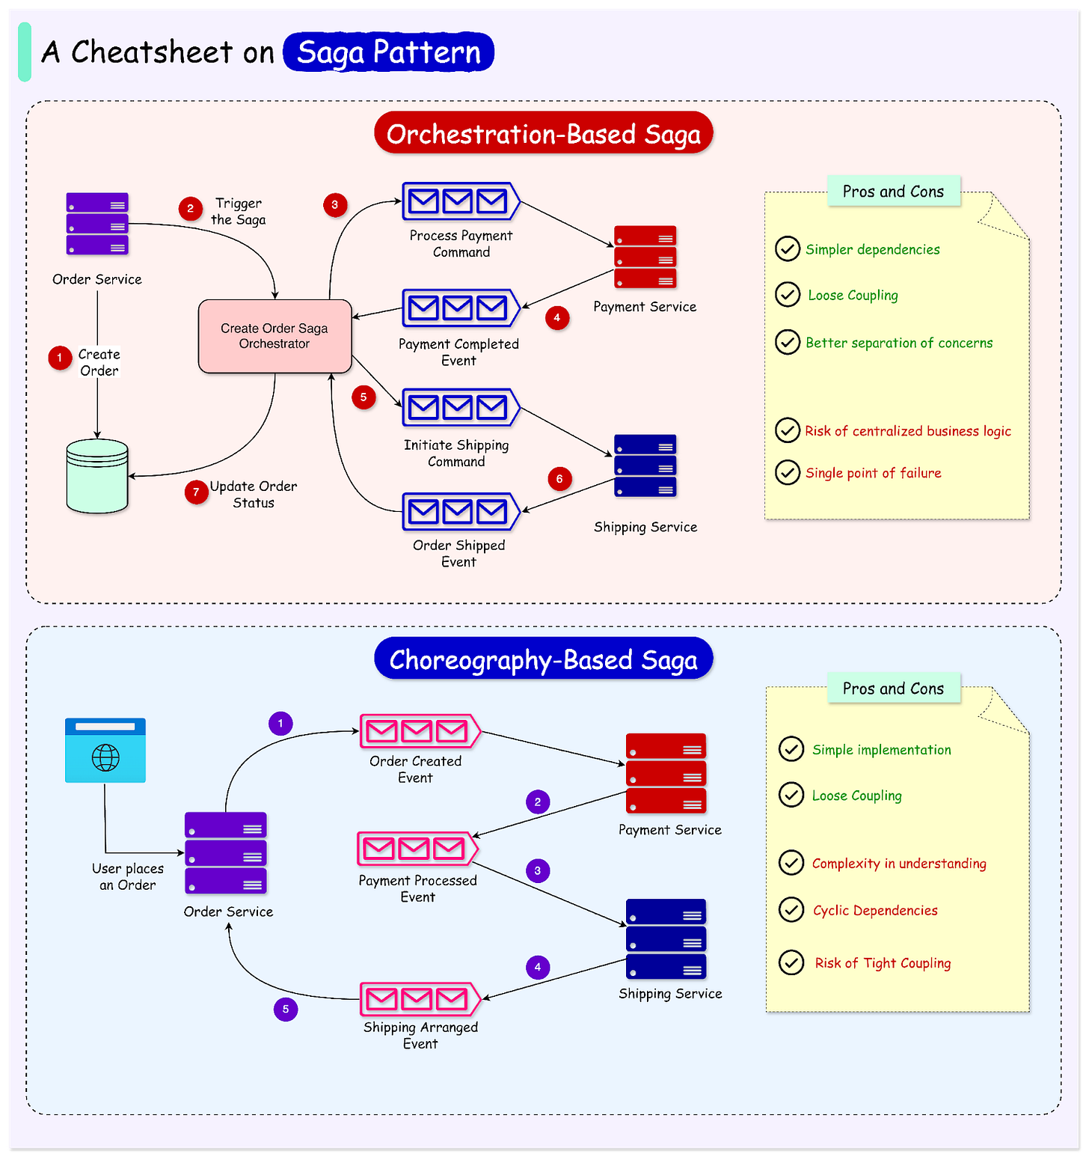

🔹 Analogy
Think of Saga like a travel booking:
- Flight booked ✅
- Hotel booked ✅
- Car rental ❌ fails
👉 Saga cancels hotel & flight (compensation).

🔹 Key Rules
- Local transaction only: each service updates only its own DB.
- Events drive flow (choreography) or orchestrator drives flow.
- Compensation, not rollback: you undo by another action (e.g., refund, release stock), not by “undo SQL”.

✅ So in short:
Saga is a pattern to ensure data consistency across multiple microservices by chaining local transactions with compensating actions in case of failure.

